>Simassessment

X0112314

SimAssessment

Institute for interactive media and learning

Subject outline Semester 2 2002

© UTS 2002

About this Subject Outline

This subject outline contains information you will need to find your way around the subject, SimAssessment. It attempts to provide a structure for your learning, giving details of the topics, and how, when and where you can choose to study them. .

The information in this subject outline was correct at the time of printing.

Photocopies of this document for the purpose of study in this subject may be made without permission
.

Information about this subject

Subject description

This subject is designed to develop your understanding of assessment in higher education and the relationships between student learning, educational goals and assessment. Assessment criteria focus on encouraging you to reflect on and critique an aspect of your own assessment practice and propose alternatives which encourage improved student learning.

Learning objectives

By the time you have successfully completed this subject, you should:

- Enhance their understanding of the relationship between assessment, learning objectives and student learning in higher education
- Distinguish between assessment for feedback and assessment for grading or certification
- Apply these understandings through critical reflection on assessment in their subject
- apply techniques for standardising marking.
- apply techniques for developing explicit outcomes and criteria
- apply techniques for providing feedback for student learning
develop strategies for involving students in assessment

How this subject is organised and what we expect of you

This subject takes you on a journey into the past, present and future of assessment and its relationship to teaching and learning. Each module will have a theme, which your module staff will tell you about in your first lecture.

One of the aims of this subject is to introduce you to the idea of balanced assessment pattern - of creating an environment in which students achieve high quality learning outcomes. You will have the opportunity to develop a vision of how assessment can contribute towards a better learning, by drawing on knowledge you will gain about the principles of a balanced assessment pattern, and the lessons learnt from the histories of, and current assessment practices. What should “ethics” mean in assessment practice of the future? What should professionalism mean? Can we assume that a better assessment leads to better learning? future is a better future? How are answers to these questions underpinned by society’s values?

You will be staying and studying with the one module group for the whole semester. This means that you will get to know some of your peers and staff members well, as well as gaining an overview of one theme area in assessment. All module themes are cross-disciplinary; that is they address issues relevant to all fields of assessment. In whatever module group you spend your semester, you should expect (and demand) a very enriching experience.

There will be a mix of lectures, workshops, smaller group discussions and tutorials facilitated by one or more of the academics associated with your module. You will be completing some of your assessment tasks individually, and some in small groups.

The teaching staff - who are your lecturers and tutors?

Your teachers are drawn from the a cross-section of academic staff from across the University who want to share their knowledge and experiences with you, hear and learn from the views of assessment.

If you have a question about this subject

Check this subject outline. It covers many common admin and general information questions, for example about assessment requirements and due dates.

Check the "Frequently asked questions" forum in this subject on UTS-Online. If your question has not already been asked and answered, post it in the forum and it will be responded to within two working days during semester time.

f you wish to discuss your questions or need further help with understanding concepts in the subject, please see the lecturer after lectures, or during consultation hours. If you are unable to come then, please email and suggest several alternative times when you will be available. Email messages will be responded to within two working days.

Subject timetable: topics and teaching and learning activities

Minor changes may be made during the semester; in such cases, announcements will be made in class.

Semester Week  Beginning | Primary session (Monday) | Secondary session (Friday)
1  30 July | Plenary  Welcome & introduction  What is this subject about? What is this module about?  Workshop  What is assessment? What is learning? | Plenary  Overview of Assessment task 1  Resource session: Academic reading  Tutorial  Discussion of "Ethics, Professionalism and the Pleasures of assessment"  Forming learning partnerships
2  6 August | Plenary  Video: Limits to assessment  Workshop  Debrief of video  Why theory?  Preparing to read "Assessment and History - | Tutorial  Why study history?  Discussion of "Assessment and History -  Brainstorming case study topics
3  13 August | Plenary  Overview of Assessment task 2  Resource session: Planning & researching for the case study report  Resource session: Introduction to UTS Online, the EfS Library page & UTS BELL  Workshop  Assessing thinking  " | Tutorial  Preparing a case study proposal  Applying a assessment framework  Discussion of "The Evolution of Large assessment Systems"
4  20 August | Plenary  Assessment in historical context: case study presentation  Workshop  Debriefing case study presentation  Working in learning partnerships to refine the case study proposal | Tutorial
5  27 August April | Tutorial  Plenary  assessment in the contemporary Australian context | Tutorial  Assessment as a challenge for teachers
6  3 September | Plenary  Resource session: Writing the case study report  Why assessment? What is assessment? Can assessment lead to learning? | Tutorial  Assessemnt as a pie in the sky?  Discussion of "The test in the City"  Discussion of BELL teamwork resource
7  10 September | Plenary  Overview of assessment task 3 & class project  Resource session: Introduction to UTS BELL - Working in teams  Workshop  Forming teams & planning for assessment task 3 & the class project | Workshop
8  17 September | No formal classes
9  24 September | No formal classes
10  1 October | Labour Day public holiday  No classes | Tutorial  Learning to work in groups and teams  Discussion of "Conflict on Collaborative Design

Assessment

Assessment tasks

For many students this is the most important part of the subject outline. Clear communication of assessment requirements at the beginning of the subject can save students and staff a lot of time and frustration later. The Assessment Procedures Manual (2001, pp10-11) includes a list of information which must be provided to students

Minimum essential requirements for students in this subject

In order to pass the subject, you must

> attempt, complete, and submit all assessment tasks and
> receive 50% or more of the marks for each of the assessment tasks; and
> earn an overall total of 50 marks or more for the subject.

Workshops are an important part of the learning experience in this subject. Students are expected to attend and participate in learning activities in all workshops. Students who miss more than one workshop without providing documented evidence of illness or misadventure will not be eligible for special consideration in this subject.

Assessment procedures and advice

Students are expected to refer to the following information in conjunction with information about assessment at UTS which is published in "Coursework Assessment Policy and Procedures" available via the UTSWebsite at http://www.uts.edu.au/ xxxx/.

Presentation of assignments

Assignments must be presented using the format outlined on pages x-y of the "Guidelines for preparation and presentation of written assignments" from the Faculty ouline. You are advised to pay particular attention to the procedures for Referencing. You must attach a completed and signed cover sheet to the front of each assignment.

You should present all your written work (unless otherwise instructed) so that
> it is easily legible (it does not have to be typed)
> it is written/printed on A4 size paper
> it has the cover sheet (use attached cover sheet) with your name, student number, and module group clearly labelled, and the signed declaration of originality;
> it has the feedback sheet attached at the front as page 2
> the total word count indicated in each assessment is respected
> there is at least a 2 cm margin around the text on each page for comments from the assessor
> all the pages, including the cover sheet and the feedback sheet, are stapled together on the top left hand corner

Please do not place your work in a plastic sleeve, folder, binder etc. You should submit your assignment as directed by your module presenters on the due date.

Assignment submission

Students need to retain a hard copy of all submitted assignments.

Return of assignments

The assignments will be returned and any processes for returning posted or electronically submitted assignments or assignments submitted after the end of semester. If you wish to have your assignment posted back to you, please attach a stamped, self-addressed envelope when you submit your assignment.

Grades

This subject will have the usual range of grades which will be awarded in the subject and the conditions whish students need to meet to gain different grades.

Extensions and late assignments

Requests for assignment extensions need to be made to the subject co-ordinator in writing before the due date of the assignment. Extensions are not automatically granted. They are usually given only for unexpected circumstances, such as illness or misadventure, which affected your ability to complete your assignments on time, not for commitments that you have known about for some time in advance.

If you are unable to apply for an extension before the due date, due to illness or misadventure, you must submit an application for Special Consideration with relevant documentation to support your application.

Faculty guidelines state that assignments that are submitted late, with no extension granted, will incur a penalty of 5% per working day deducted from the final mark. That is to say, 5% of the maximum mark possible for the assignment will be deducted from the mark you are awarded for the work.

Resubmission of assignments

Students who submit an unsatisfactory major assignment will be given feedback and an opportunity to resubmit the assignment, taking the feedback into account. Resubmission must take place within two weeks of the return of the assignment. Assignments may be resubmitted once only. Resubmitted assignments cannot gain more than 50% of the marks available for the assignment.

Referencing requirements

Students must reference all sources used in their assignments in this subject. Please use the referencing conventions outlined in the Faculty of X Guide to Written Assignments, which is a required reference for this subject.

Plagiarism and cheating

When you study at university you are expected to earn your degree through showing what you have learned in your subjects. In most university assignments you are expected to refer to the ideas of people with "authority" in the subject area. Referring to ideas from books, journal articles, internet sites etc shows readers that you have researched your topic and considered a range of evidence. But when you use ideas from these sources - either by directly quoting (copying word-for-word) or rewording from the source (paraphrasing & summarising), you need to reference the source. This shows that you acknowledge the original authors of the theories, ideas, findings and materials that you have used. You are expected to use the academic referencing conventions described in the “Faculty guide to written assignments” in all assignments in this subject.

If you do not reference your sources, or if you copy work from others, you are taking someone else's words or ideas and trying to pass them off as your own. This is plagiarism. Plagiarism is cheating and academic fraud.

Plagiarism includes

> Quoting, rewording or summarising ideas from books, journals, newspapers, internet sites, the text book, lecture notes or other sources without referencing the original source;
> Copying and pasting phrases, sentences or paragraphs from material on the internet without referencing the original source. (Cutting and pasting chunks of material with acknowledgement is not plagiarism but is generally poor academic practice.) ;
> Downloading or purchasing assignments from internet sites and submitting them under your own name;
> Copying from another student or submitting an assignment done by another student under your own name. This includes submitting something which you have modified or paraphrased but is substantially someone else's work.

Students who are found to have plagiarised will be penalised in line with university policy. Penalties may include failing the assessment task or failing the entire subject. Serious cases of plagiarism may attract more severe penalties. Allowing your work to be plagiarised is allowing cheating and will also be penalised.

Please note that lecturers have access to resources which can be used to check for evidence of plagiarism from internet sites. These resources may be used when plagiarism is suspected or may be used randomly to check assignments.

What is the difference between working with others and plagiarism?

Learning with other students is a valuable part of university. You can learn a lot from studying in groups, discussing assessment topics, debating ideas, sharing some resources, or reading and giving feedback on other students' draft assignments. These learning activities are not plagiarism. But if you are doing an individual assignment, you must prepare, write and submit the work yourself. If you are doing a group assignment, then it must be prepared and submitted by the students belonging to your group. If you are not clear about whether something might be plagiarism, consult your lecturer or tutor.

Further information about academic integrity and avoiding plagiarism can be found in the UTS "Guidelines on Good Academic Practice”.

Assessment adjustments (special conditions)

Students may apply for alternative assessments or special conditions for examinations in accordance with University rules. Students should approach the Faculty's Academic Liaison Officer (ALO). The ALO is a member of academic staff who receives and determines requests for:
> assessment adjustments from students who have permanent or temporary disabilities;
> special provision for students who are sole carers.

These requests are negotiated on terms, which are acceptable to the staff and students concerned. It should be noted that all requests for assessment adjustments should be finalised by Teaching Week 11 except where the need could not have been known beforehand. It is extremely difficult to process any requests after this date.

Special consideration

If you miss the final exam or believe that your performance in the exam or another assessment item was affected by illness or misadventure you may apply for special consideration. You must complete and submit the Special Consideration form, available from the Faculty student office or UTS Information office. Please follow the instructions on the form and supply relevant documents to support your request.

Learning resources

UTS Library

You will be expected to use library resources such as books, journals, online databases etc as part of this subject.

Many library resources are available to you online via the Library’s web site http://www.lib.uts.edu.au

If you wish to access library resources from outside UTS, you should read the information available at:
http://www.lib.uts.edu.au/services/off_campus
You will need a username and password to access library resources like databases etc from outside UTS. This will be the username and password of your UTS Email account (not your UTSOnline account, which uses your student number).

If you haven't yet activated your UTS Email account, please go to http://webmail.uts.edu.au
If you have trouble activating your UTS email account, please visit one of the IT Support Centre counters at UTS, ring the ITD helpdesk on 9514 2222, or email them at itsc@uts.edu.au

Instructions on how to set up your computer to access the library's resources can be found at:
http://www.lib.uts.edu.au/services/off_campus/access

The library web site also offers some online tutorials to help you to develop your Information skills:
A tutorial about finding information on the web is available at:
http://www.lib.uts.edu.au/information/tutorial_index

A tutorial about using Catalyst for research and investigative assignments is at: http://www.lib.uts.edu.au/catalyst/

Details of library locations and hours are available on the Library’s home page

UTSOnline

UTSOnline is a web-based computer mediated communication package and can be accessed by most web browsers from inside or outside the university.

How do I log in?

The URL for the UTSOnline log in page is:
http://online.uts.edu.au/

You will need to log in to UTSOnline each time you use it.
Your user name is your student number
Your default password to begin with is the first two letters of your family name (IN CAPS) followed by your student number

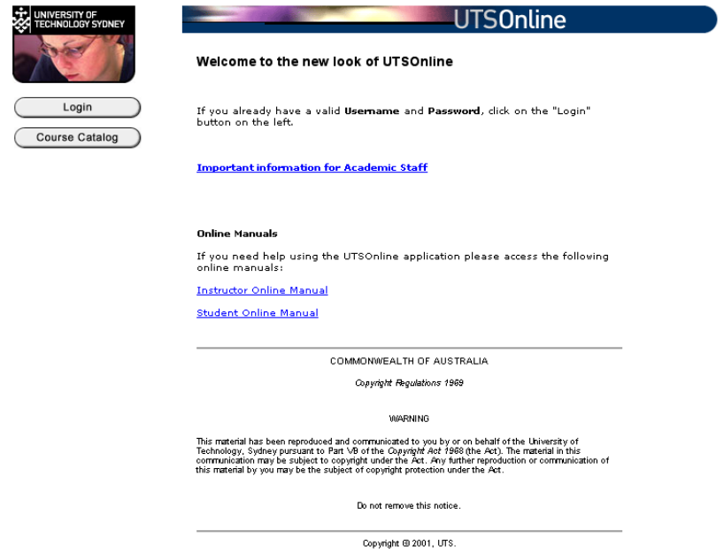
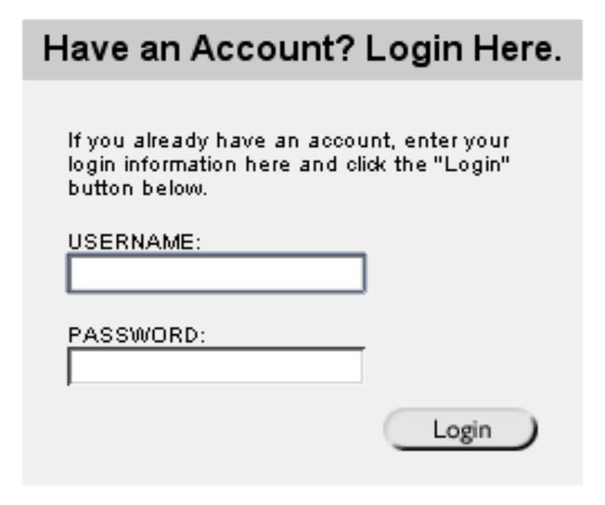
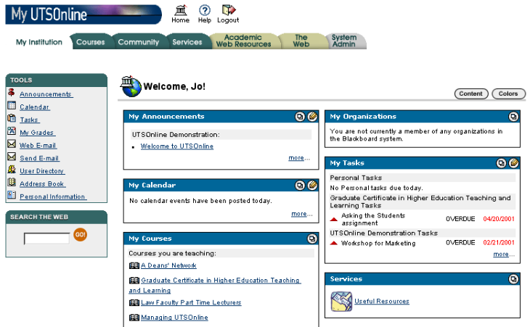
student number eg 12345678
Default = first two letters of family name (IN CAPS) then student number eg AB12345678
Don’t forget to change your password!
Click Login to go to the login window
After you’ve logged in, you’ll see your personal home page
You should see a link with the name of this subject under the “My courses” bar.
Understanding learning in…

If you are having problems logging on or forget your password, contact the ITD helpdesk on x2222 or help.desk@uts.edu.au

After you’ve clicked on the course link, your screen will show the following buttons down the left-hand side.



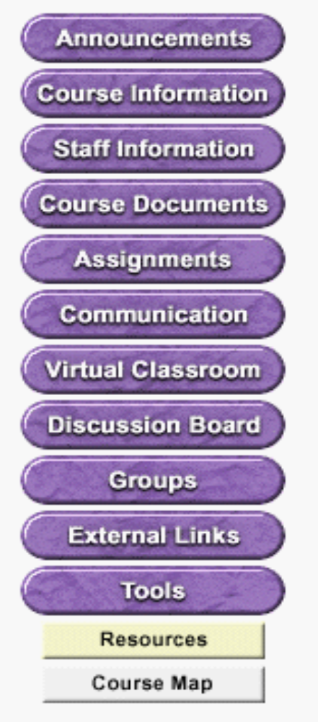
Access your subject outline and other public information about the subject
Find contact details for lecturers & tutors
Access any subject materials provided online eg tutorial guides, additional notes
Find assignment information, maybe test yourself with quizzes and answer surveys
Send email, find other students’ names and home pages on the roster
Find link to useful websites for the subject
Check your grades, submit assignments
in dropbox, edit your home page, change your password, access the help manual
Read your subject announcements to keep yourself up to date
Access an outline of the UTSOnline site
for the subject
For real-time communication
Ask questions about the subject, participate in discussion forums
Have group discussions, exchange files with group members
Don’t forget to logout
Access your other subjects

How to change your email address in UTSOnline

When you are first given an account in UTSOnline, your email address is set to changeme@uts.edu.au. You need to change this to your preferred email address so that the lecturer and other students can contact you.

To change your email address, follow the four steps indicated:

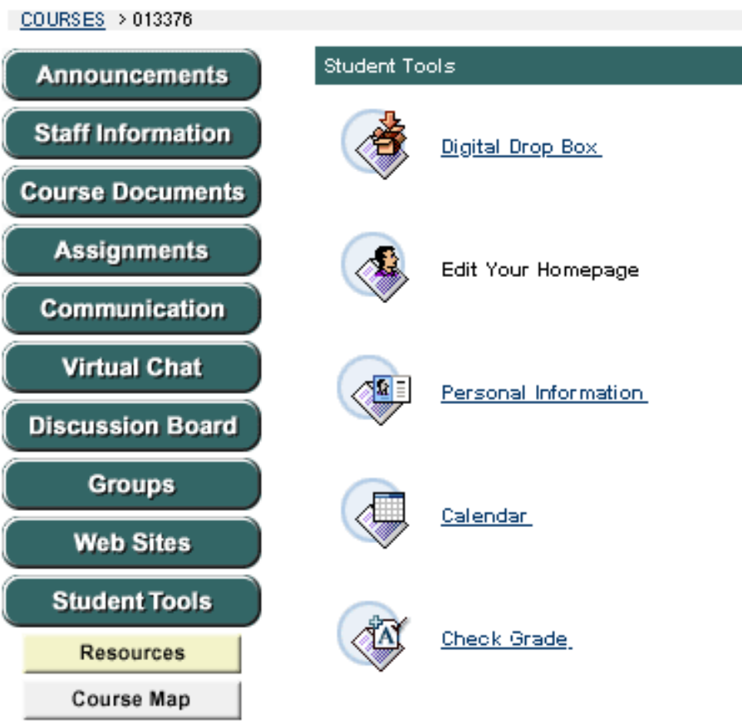
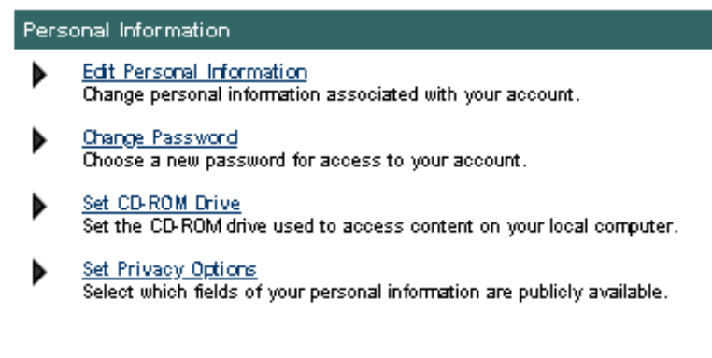
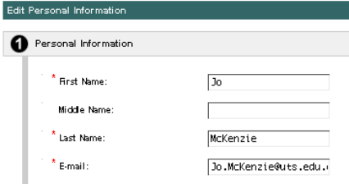
Click on the Student Tools button
Click on the Personal Information link
1
2
To change your email address click on Edit Personal Information

3
Enter your preferred email address, then scroll down to the bottom of the screen and click the Submit button
4

Submitting assignments through the Digital Dropbox
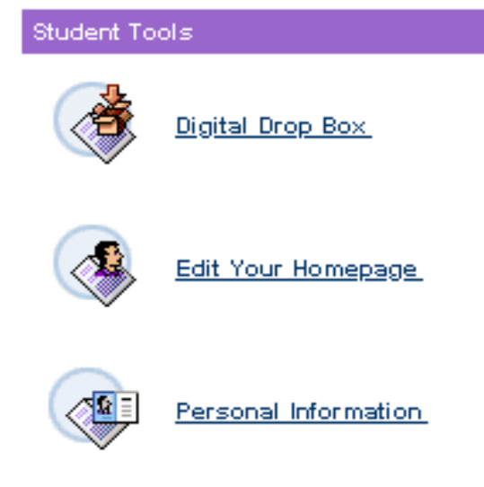
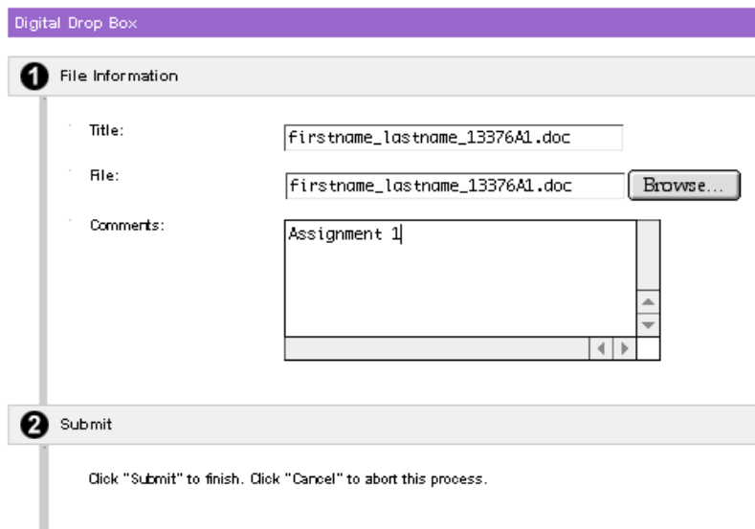
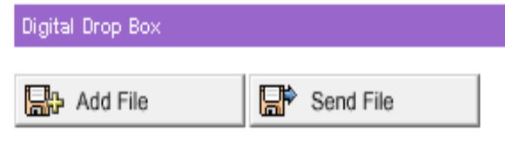
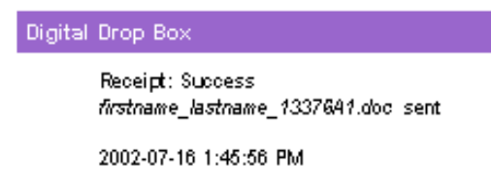
Click on this link and you'll see two buttons, as below.
Click Send File to submit your assignment to the lecturer. (Clicking Add will not submit it.)
Title the file with the file name. Comments are optional
After you've clicked the Submit button, check that the receipt says sent
Browse your hard disk to find and select your assignment file - check that its name is the same as the title.
1
2
3
4
To SEND your assignment electronically via the digital dropbox in UTSOnline:
Make sure that your file is in a common format such as Word or rtf.
Name your file using the following convention (Mac users please add a file extension like .doc or .rtf so that UTSOnline will upload your file correctly):
Yourfirstname_yourlastname_subjectnumberA1.doc for Assignment 1
Your firstname_yourlastname_subjectnumberA2.doc for Assignment 2
Also use this name as the title of the file when you submit, so that I know it's your assignment when it arrives in my dropbox
The digital dropbox can be found by clicking on the Student Tools button:

Student support and other information

Developing your learning skills
The BELL (Becoming an Effective Lifelong Learner) website provides information, self-testing and links to help you to develop your learning and teamwork skills. http://www.bell.uts.edu.au/bells/

Assignment writing, oral presentation, Academic English
The ELSSA (English Language and Study Skills Assistance) centre offers language and study skills support. http://www.uts.edu.au/div/elssa/

Mathematics, Statistics and Introductory Computer skills
Contact the Mathematics Study centre for help with introductory mathematical or quantitative areas including statistics, or introductory computer skills. http://it.uts.edu.au/activities/msc/

Computer logins, passwords and computer labs
Contact the ITD (Information Technology Division) help desk if you are having difficulty logging on to the UTS Website, your UTS Email or UTSOnline. Phone: 02 9514 2222 Email: helpdesk@uts.edu.au

Organising your study, motivating and managing yourself

Contact Student Services: http://www.uts.edu.au/div/ssu/index.html

Help with subject enrolment, forms for special conditions, etc…
Contact the Faculty student office (or whatever ...)

